**VPN IP not displaying on Menu page of Delious machine**

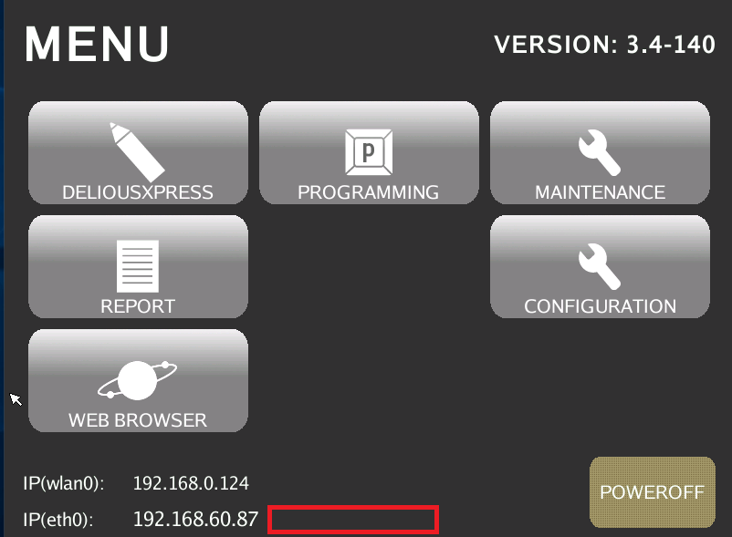

Go to [Menu] > [Configuration] > [2] > [VPN Client Configuration]

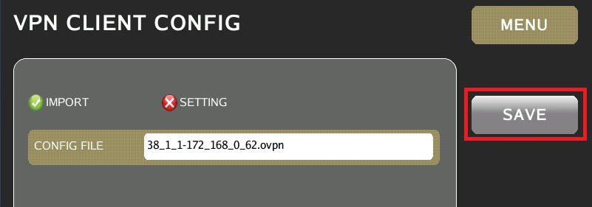

Make sure the CONFIG FILE exists in the field and tap on SAVE button.